Working title: Echoes from beyond

1. Project structure

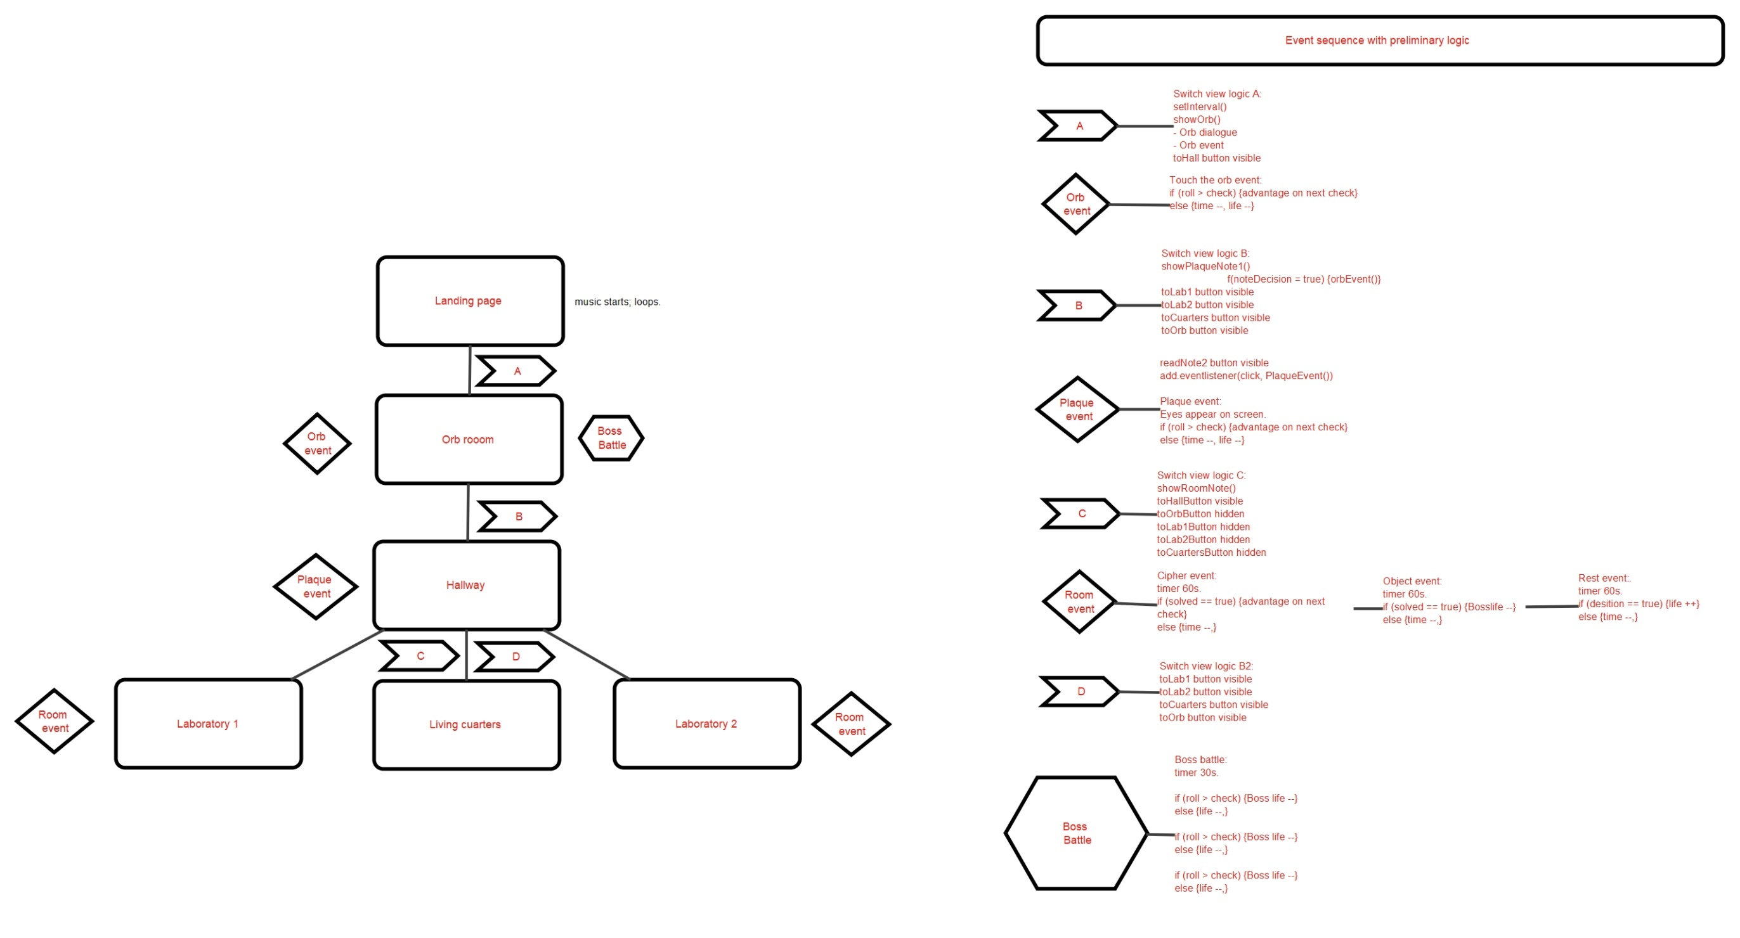

Extra thoughts:

1. Sounds for doors opening
2. Sounds for Caesar cipher switching
3. Sounds for backpack inclusion (hidden object event)
4. Attack sounds

II. Project structure with outline

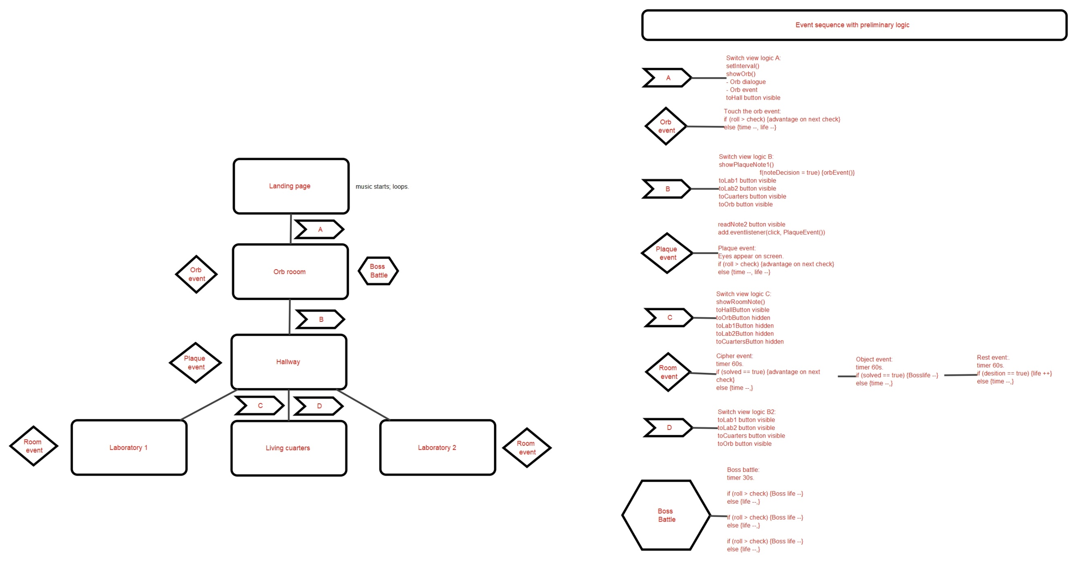

III. Text notes

1. Landing page note

Fellow hunters,

I understand this situation may be unsettling. However, it is crucial that you heed my instructions to the best of your abilities. Regrettably, I cannot provide further details, it could endanger us all. Rest assured; we are embarking on a hunt for the most dangerous quarry our organization has ever faced. More information awaits within the containment chamber.

Upon ingress, the doors will seal behind you. You will be contained inside until the sequence automatically initiates 24 hours later. It is imperative not to overlook this timeframe. Refrain from bringing more rations than necessary for the allotted 24 hours. Lastly, under no circumstances should you take anything out of the containment vault. Wishing you all the best of luck.

Your mentor,

Dustin

1. Plaque note 1

Note 1:

`Hi player array 1, Hi player array 2, Hi player array 3, Hi player array 4, and of course, hi me. Yeah, yeah this is weird. I’m taking to myself via letters. It’s a shitty situation. Nobody likes to be on lockdown particularly after 2020, and specially with these guys as company! If it’s any consolation – this is not the first time you’ve been here! As best as we gather, this has happened quite a few times before. Hell, I’d bet it’s been going on ever since good ol’ Dusty on us disappeared 7 years ago. But yeah, enough chit chat. His warning is real. This place contains an ancient secret we are trying to fight. We’re picking up Dustin’s slack after he went on break and never came back. Someone went and torched all the notes for some reason. Luis Emmanuel, I’m looking at you! I still don’t believe the fire was an accident. So yeah, we’re stuck here trying to bootstrap a solution from remains and stuff we’ve cobbled up together. We are so close to figuring this out. The next page in this note contains the details of the threat but DON’T READ IT YET. Take your time to explore and form your own opinions. To me, with love, the ever dashing and magnificent ${currentPlayer}.`

1. Plaque note 2

Note 2:

Want to know a secret? Daniel told me this place isn’t really a containment vault. It’s a shelter. The threat is outside, somewhere… We are assuming the worst-case scenario – whatever’s out there is omniscient. This vault might be the only place in creation IT can’t directly see into. Somehow, it messes with people’s memories. It’s not invisible – it’s protected by some kind of obfuscation array. That might be for the best, since once you see it, it can also see you. The more you learn about it, the better it can find you. Yeah, it’s the abyss that looks back at you. I’m afraid that giving it a name might escalate things so I’m going to keep it vague. I don’t think it’s sentient, but it lashes out at those who perceive it. It’s incredibly lethal, erases people from memory. SHIT I now notice that I messed up, it knows you are aware of it and so IT is of you. Quick, go to the …. [unreadable].

1. Micelanea notes array

[`If something can cross over from conceptual space into reality, taking physical form, then something can cross into the opposite direction. It must be possible to take a physical entity, mechanically extract the idea it embodies, apmplify that idea and broadcast it up into the conceptual space. A bigger idea, an universal code. One designed to fight this thing.`,

`Ok, ok so hear me out. The airlock configuration isn’t necessarily tied to a 24-hour cycle. If we really wanted to leave early all we have to do is hot start the process. Maube a controlled burst of arcane energy? Maybe a magic word? Ha! I got it: Open Sesame!`,

`The monsters we’re fighting obviously aren’t natural or real. We took time to dissect a couple before their bodies vanished. Its… strange. They have no organs, no systems. Only teeth, mouths, spiny proyections of bone, teeth, and mouths. Did I say it has teeth?`,

`The protections surrounding the bunker are ingenious. The anti-divination effect is too powerful to maintain indefinitely. So it is only designed to work periodically, say every 24 hours or so. Then the protections slowly recharge over time. That stored energy is then used to power it again. The cycle must obviously be sicronized with whatever is normally preventing us from discovering this bunker hidden in the basement in the first place.`,

`How do you fight an enemy without ever discovering it exists? How do you win without even realizng youre at war? What do we do?`,

` Ok, so apparently something out there is eating our memories and triying to keep us in the dark. I say to hell with it. Let’s use what we’ve got here and scrap something together to disable the cloak and take the fight to it. We don’t really understand what is going on, but maybe we could see what we are missing. Or at least… remember. `,

`I’ve double checked the wards lining the bunker, and I didn’t find any evidence of physical, technological or arcane weakening. This is as solid and secure as it gets. Guess we have to wait for the timer to run out… Nope X that idea. The thing is here again, we cannot stay here! Whatever it is, its getting smarter. It is finding us faster. It must be pushing in harder…` ]

IV. Image resources

1. Wall Plaque A || B

<https://firefly.adobe.com/public/t2i?id=urn%3Aaaid%3Asc%3AUS%3A39f88493-61b4-4180-becf-20522c1a0baf&ff_channel=shared_link&ff_source=Text2Image>



1. Laboratory 2 Alternative 1

<https://firefly.adobe.com/public/t2i?id=urn%3Aaaid%3Asc%3AUS%3Aa3f6df49-b9d8-4ed6-8bcd-41e7b37cc76a&ff_channel=shared_link&ff_source=Text2Image>

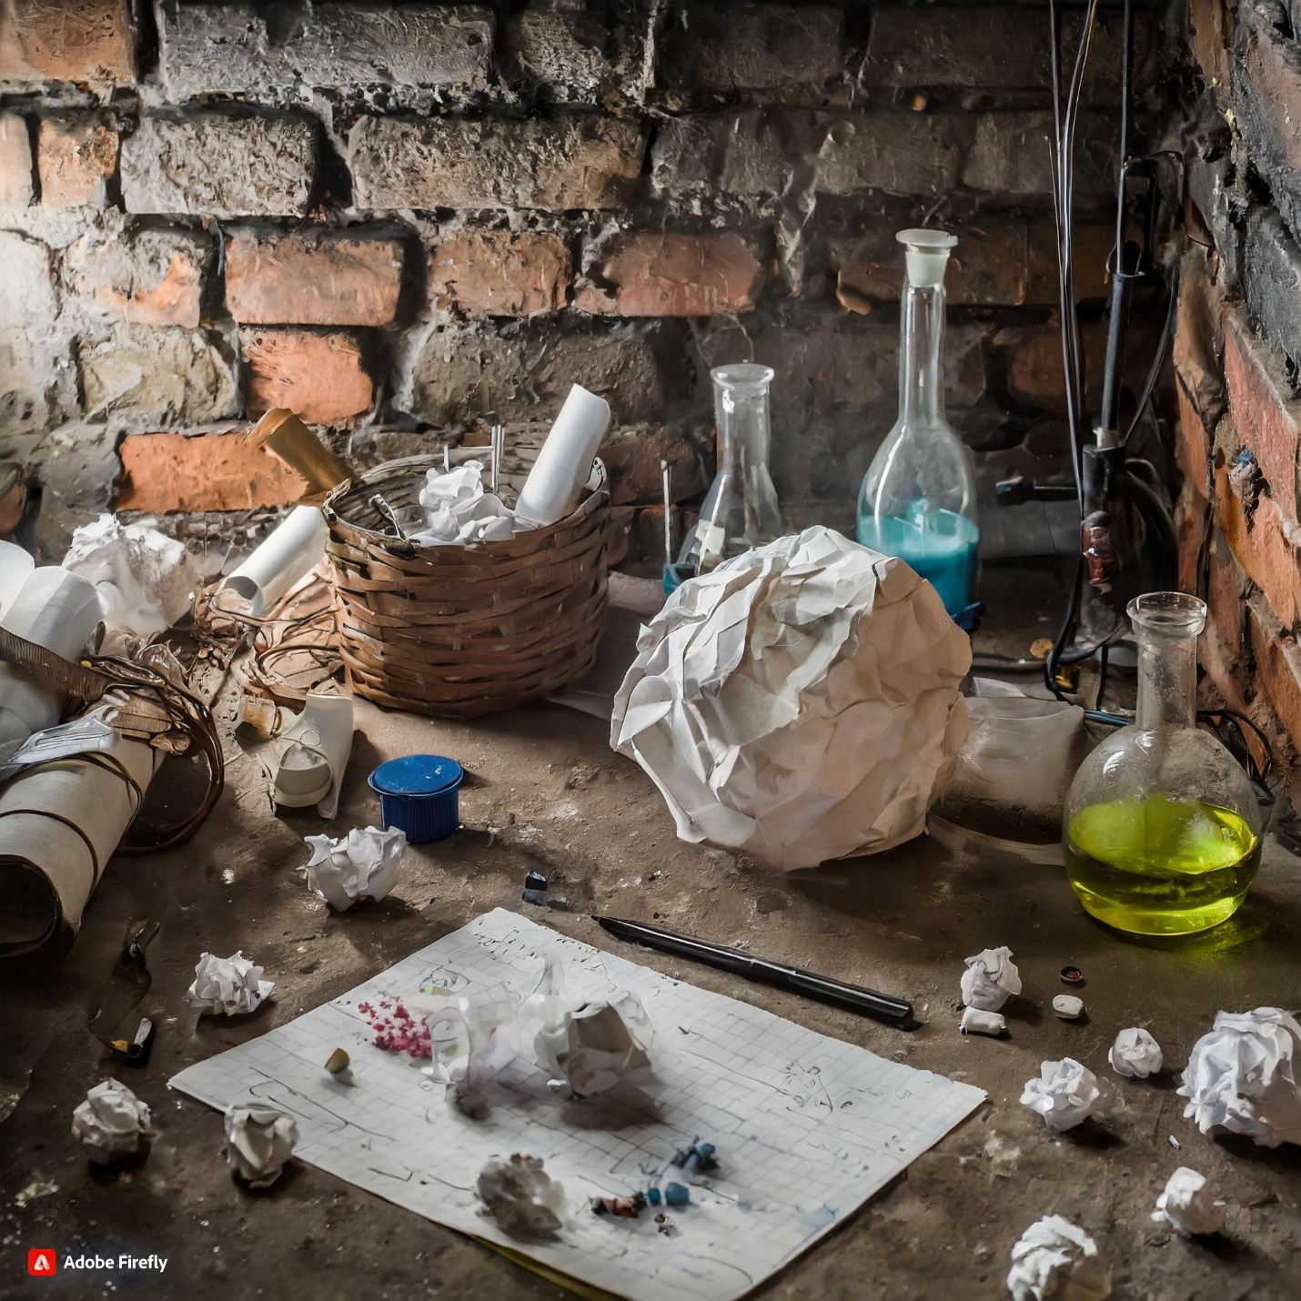

1. Laboratory 2 alternative 2:

https://firefly.adobe.com/public/t2i?id=urn%3Aaaid%3Asc%3AUS%3A6aea66b5-8641-47e6-8287-770dfb696426&ff_channel=shared_link&ff_source=Text2Image

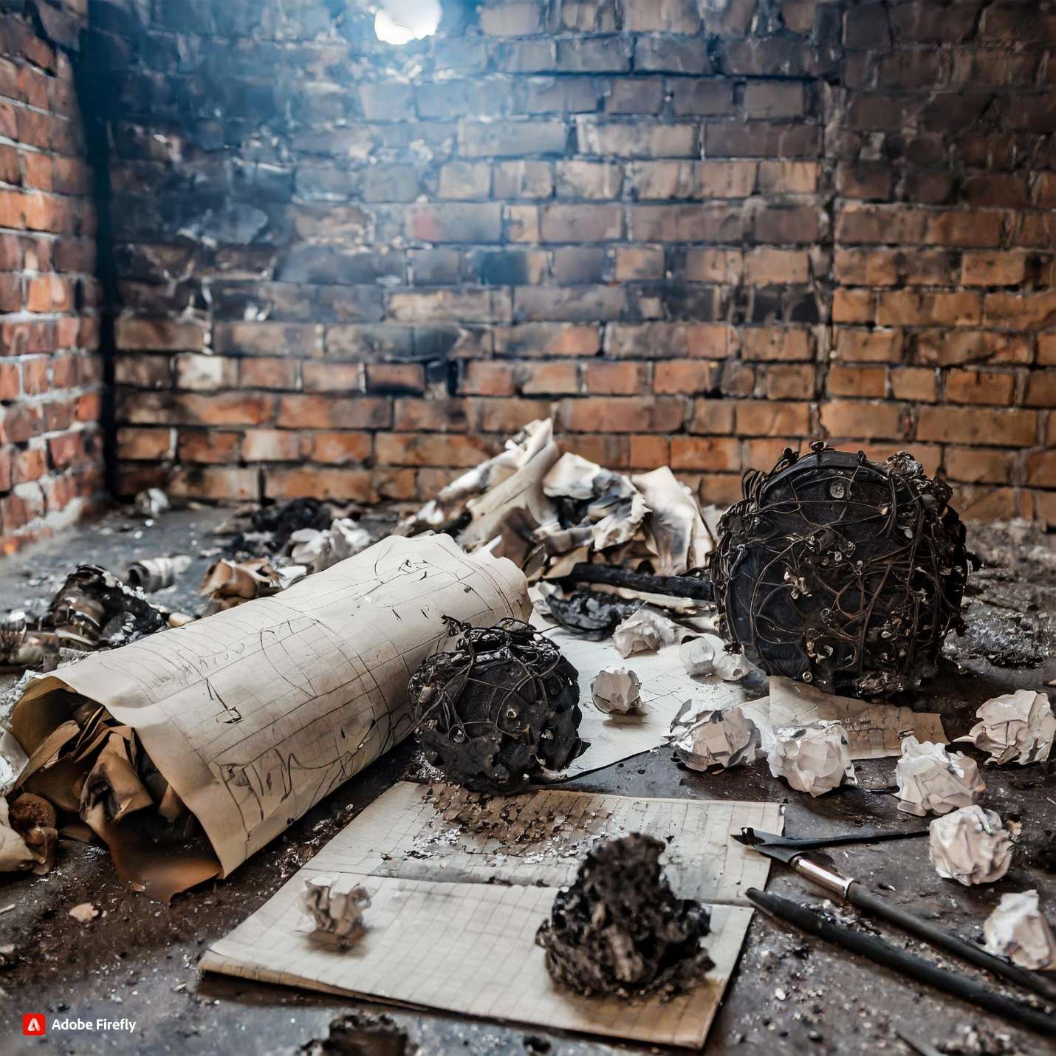

1. Living cuarters

https://firefly.adobe.com/public/t2i?id=urn%3Aaaid%3Asc%3AUS%3A53c0a107-5d1b-4583-b8f5-17eacfabe289&ff_channel=shared_link&ff_source=Text2Image

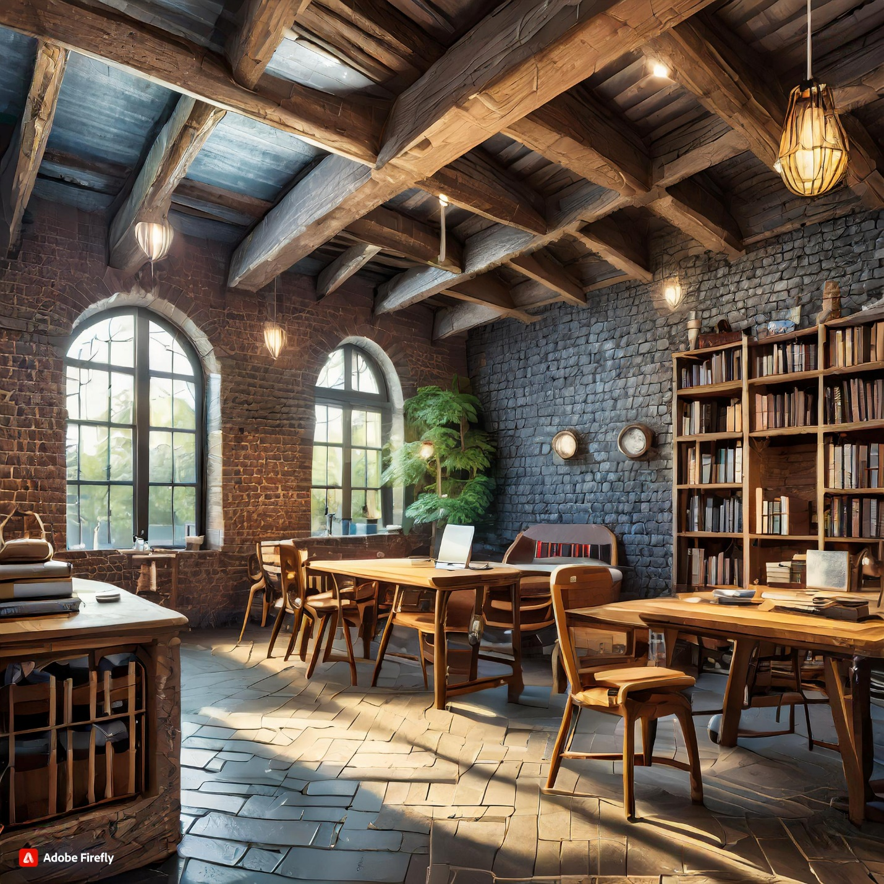

1. Hallway

<https://firefly.adobe.com/public/t2i?id=urn%3Aaaid%3Asc%3AUS%3A2a2d48cc-4bf5-45fa-97dc-8cfd21a3bbed&ff_channel=shared_link&ff_source=Text2Image>

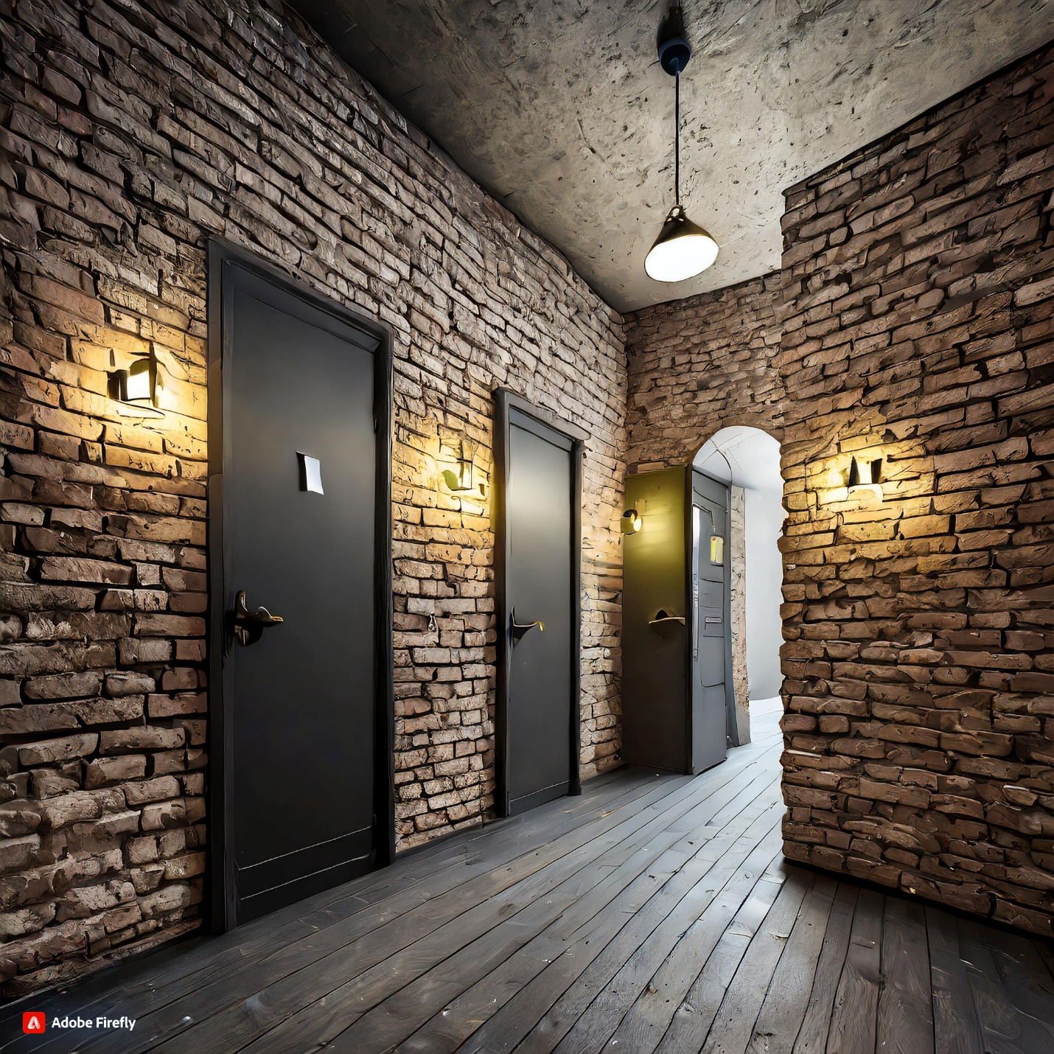

1. Orb Room

<https://firefly.adobe.com/public/t2i?id=urn%3Aaaid%3Asc%3AUS%3Ae48bb2be-e7ae-49ba-99da-9598b11a2b9c&ff_channel=shared_link&ff_source=Text2Image>

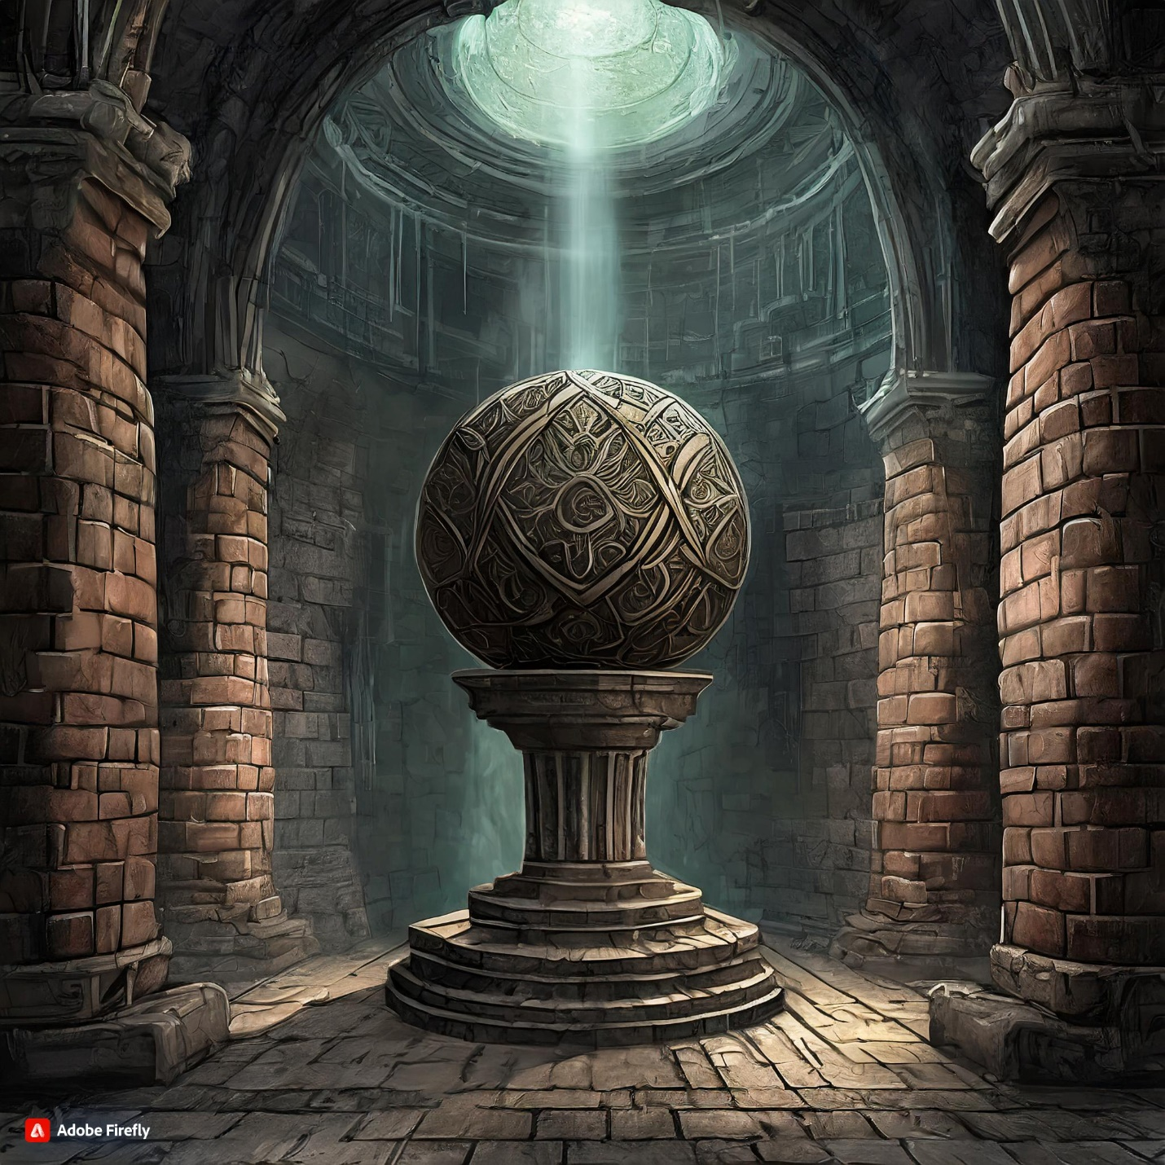

1. Laboratory 1

<https://firefly.adobe.com/public/t2i?id=urn%3Aaaid%3Asc%3AVA6C2%3A39502044-9b40-4286-9b8b-21c6eceaa4e2&ff_channel=shared_link&ff_source=Text2Image>

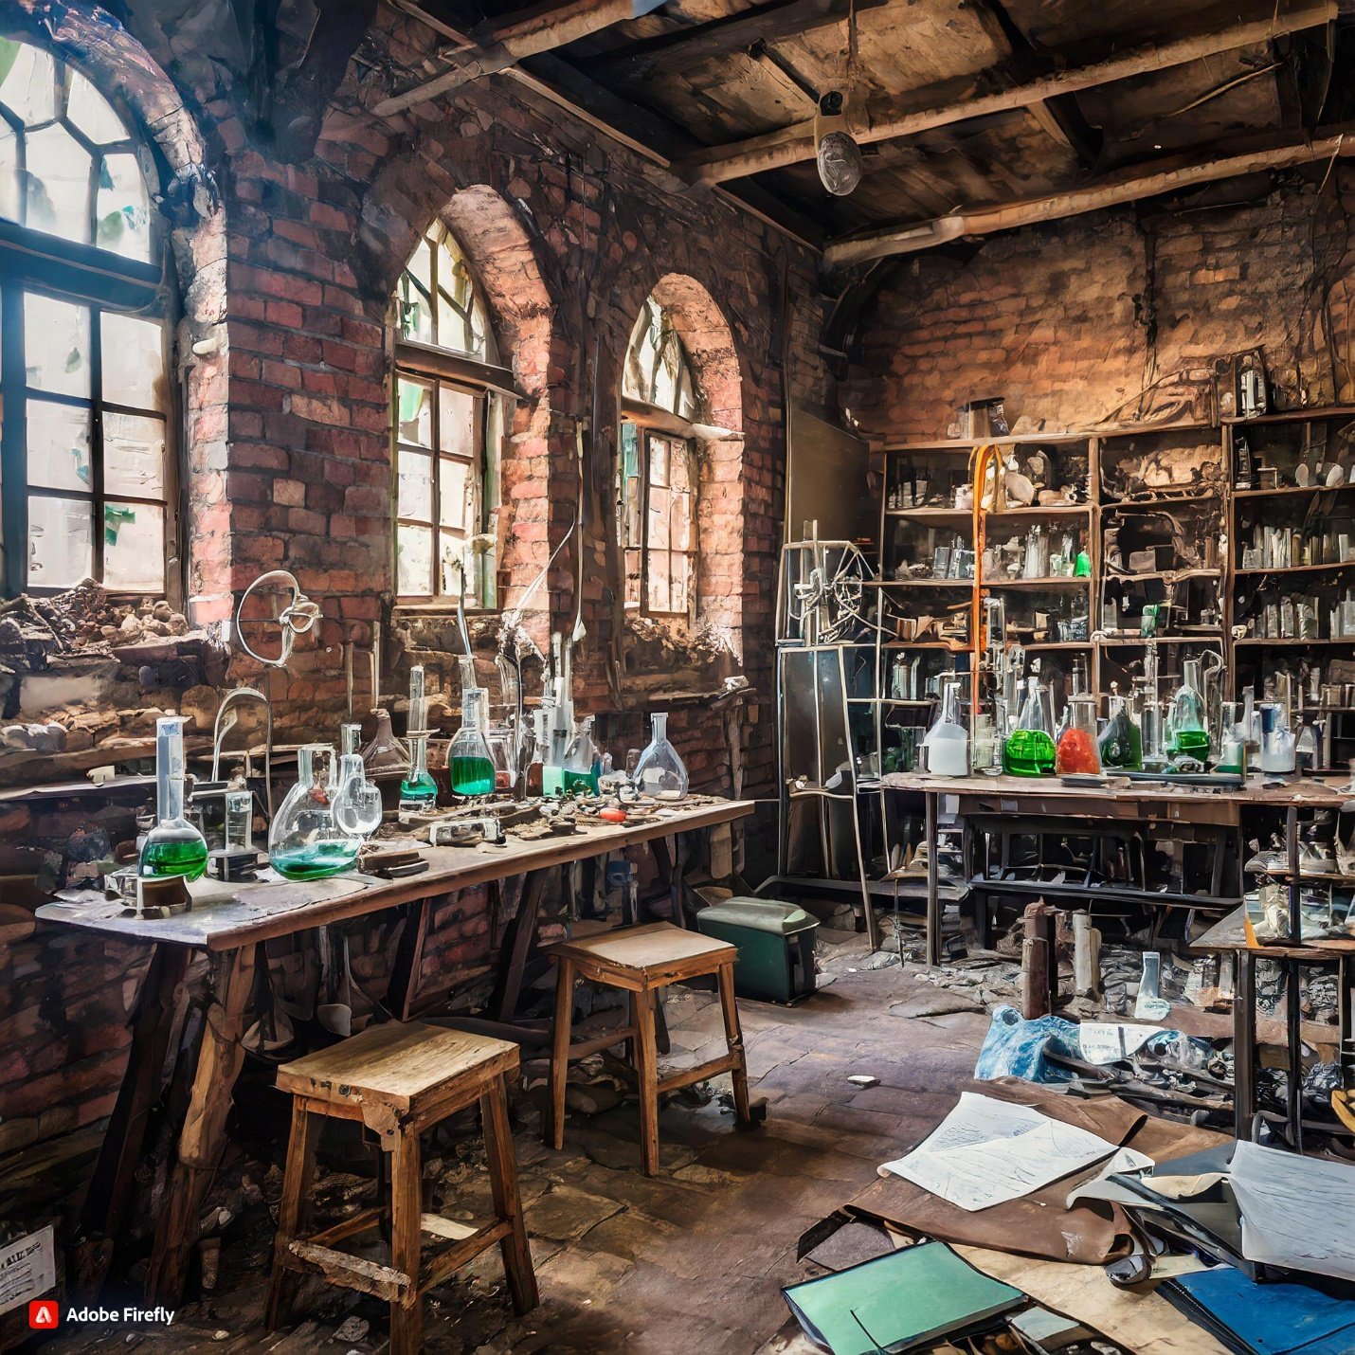

1. Boss fight

<https://static.wikia.nocookie.net/lovecraft/images/c/cf/Screenshot_20171018-093500.jpg/revision/latest/thumbnail/width/360/height/450?cb=20171020174137>

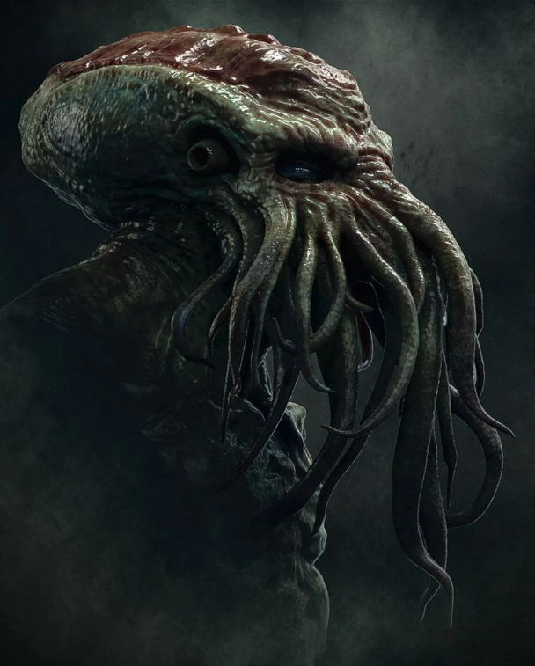

1. Plaque event

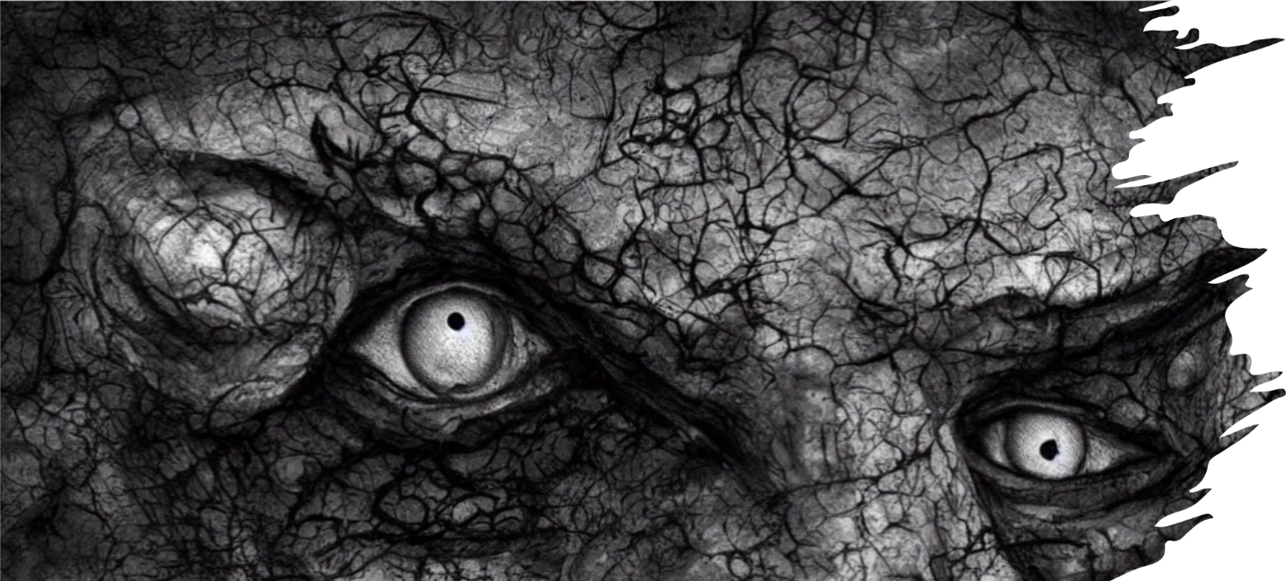

1. Game Over

<https://firefly.adobe.com/public/t2i?id=urn%3Aaaid%3Asc%3AVA6C2%3Aa862e0ee-af11-4e34-b07b-1cc446c28250&ff_channel=shared_link&ff_source=Text2Image>

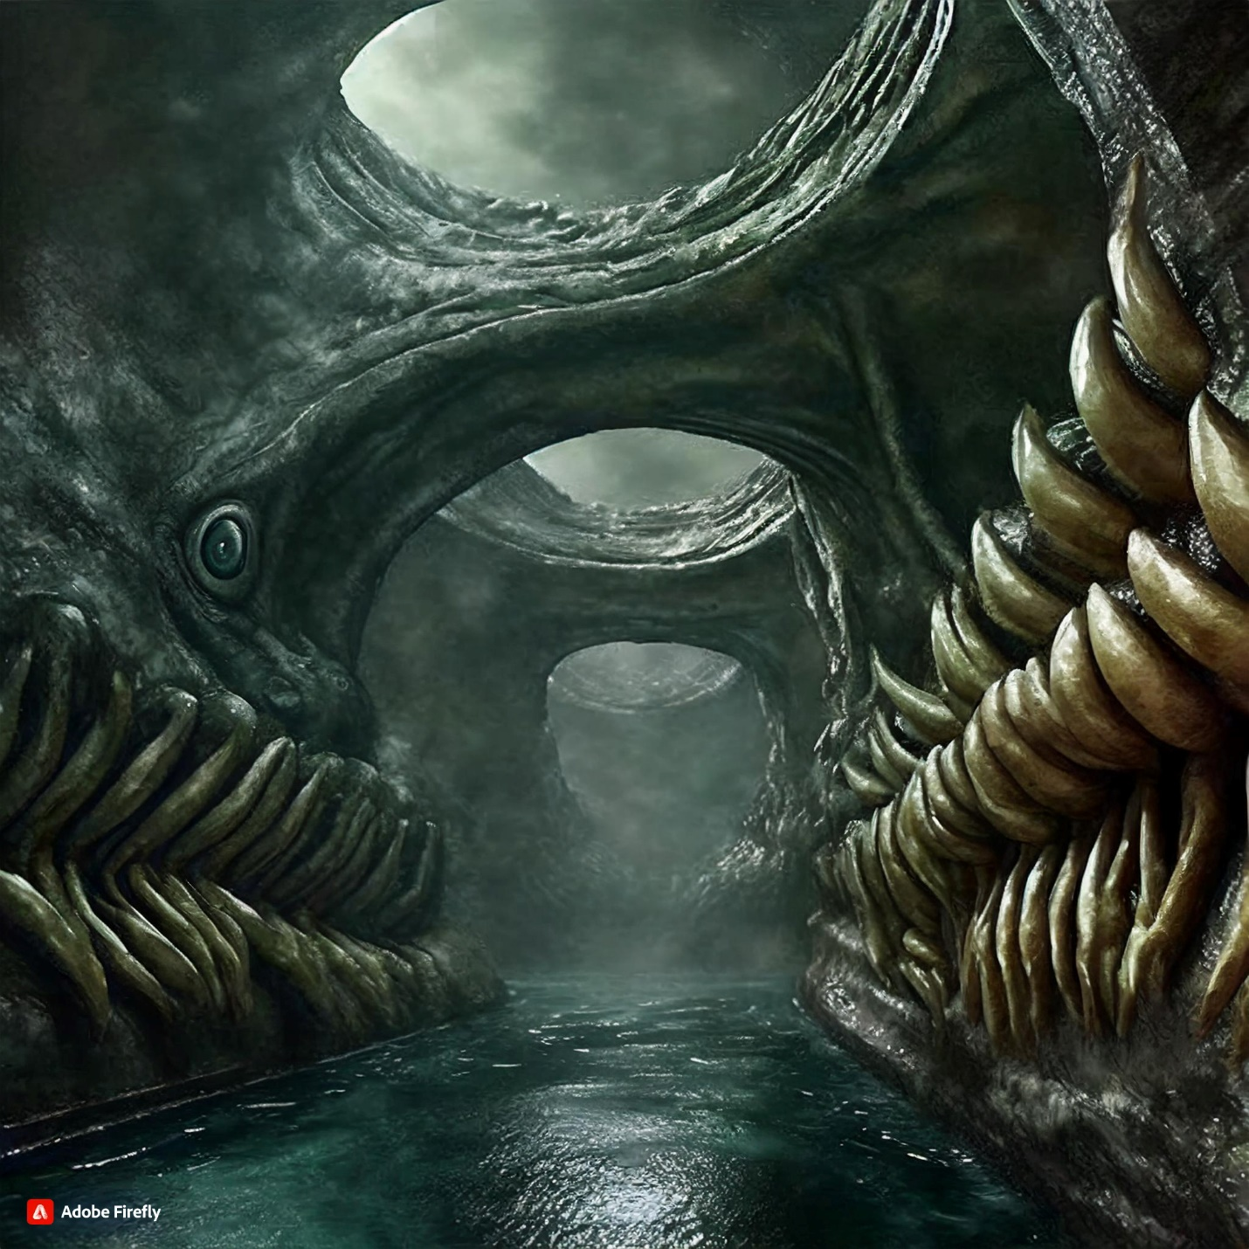

1. Landing page

<https://prompthero.com/rails/active_storage/blobs/proxy/eyJfcmFpbHMiOnsibWVzc2FnZSI6IkJBaEpJaWt3TlRBNFlqZzJOUzA1WVdJMkxUUXlZV1V0T1dZME1pMHdNR1F3TmprME4ySXhPREFHT2daRlZBPT0iLCJleHAiOm51bGwsInB1ciI6ImJsb2JfaWQifX0=--bd34b9e9ce5bc68d800eec32e7ae9ab7daebcc2f/prompthero-prompt-58d830c1fbd.png>

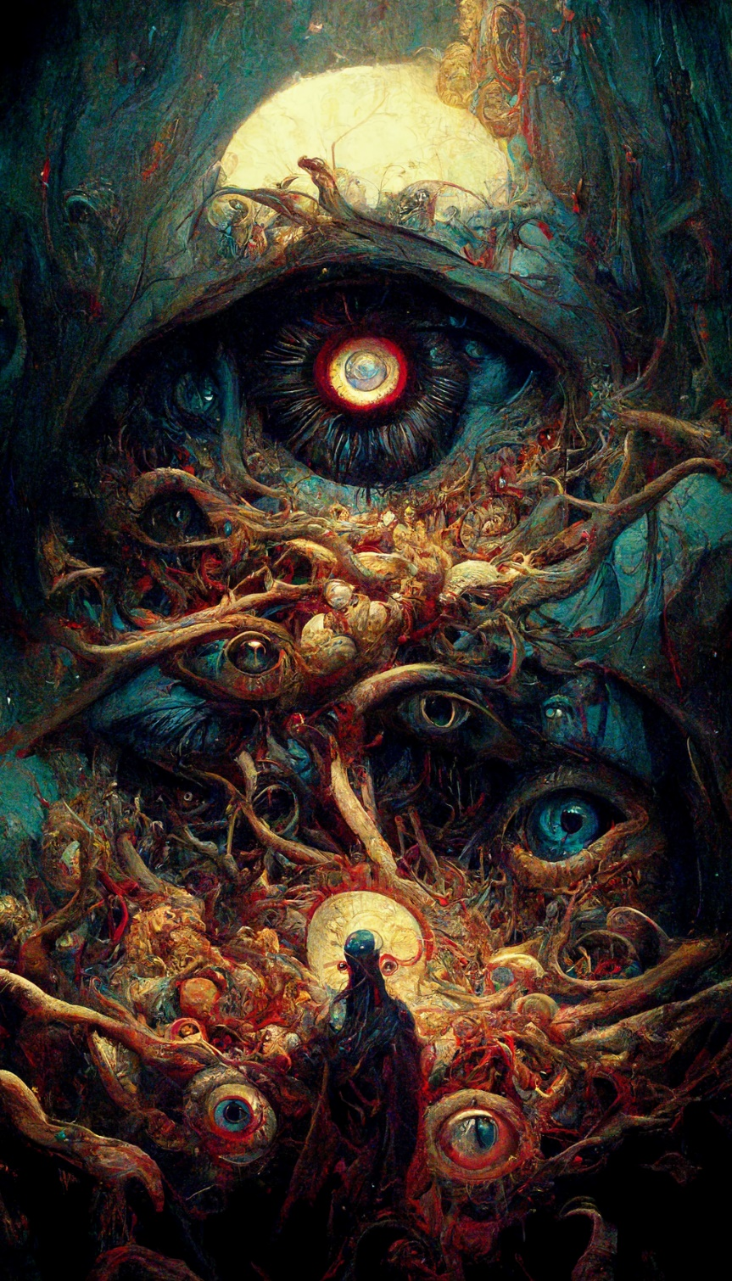

https://firefly.adobe.com/public/t2i?id=urn%3Aaaid%3Asc%3AVA6C2%3A0beb0fef-5860-497a-93d7-1292e996e7c1&ff_channel=shared_link&ff_source=Text2Image

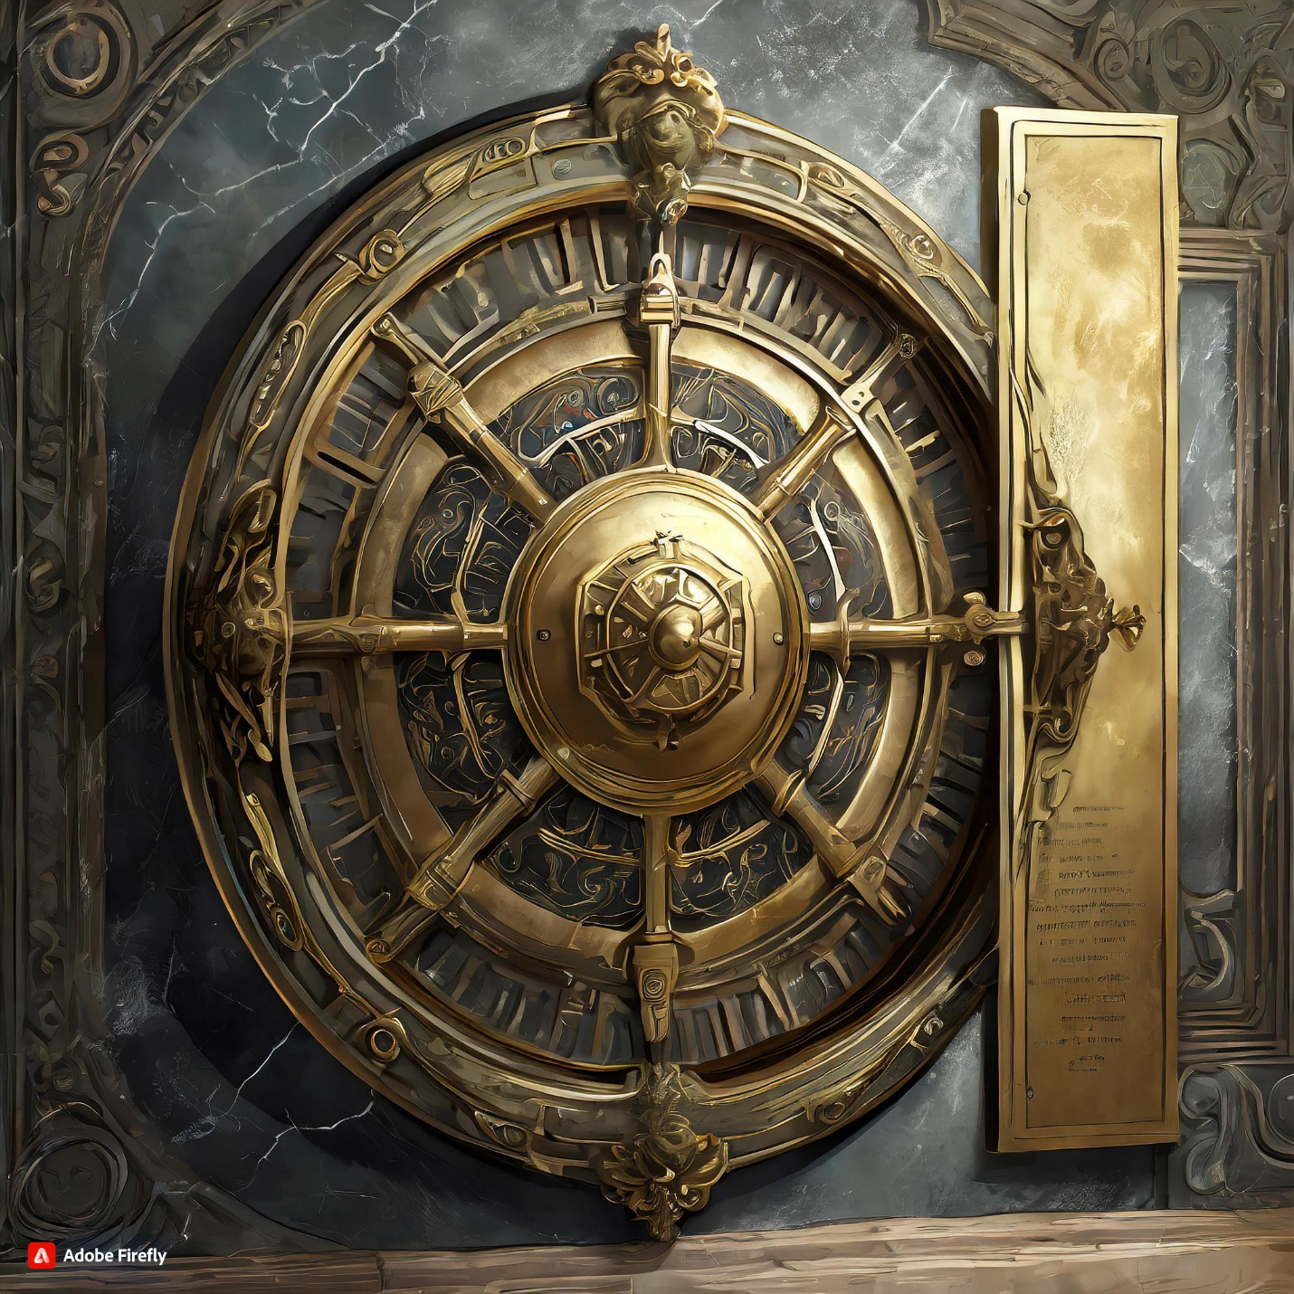

<https://firefly.adobe.com/public/t2i?id=urn%3Aaaid%3Asc%3AVA6C2%3Ab8980a89-fd36-404c-9467-64b792c6d0b5&ff_channel=shared_link&ff_source=Text2Image>

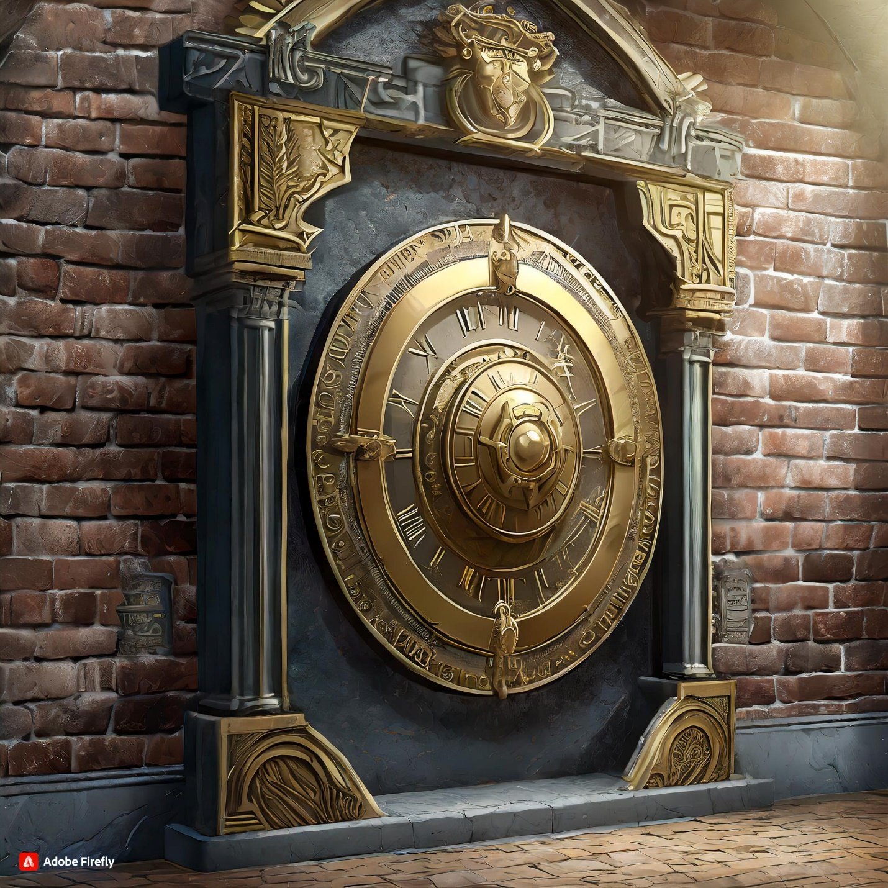

1. Project music
2. <https://www.youtube.com/watch?v=oxvDnaWe5XE&t=734s>; first 31 seconds of sound.
3. Story module credits go to U/– Adam-M: reddit <https://www.reddit.com/user/Adam-M/>